Background Information Ancient Greece Expressive Arts Activities

Ancient Greece

Why are we fascinated with ancient Greece?
The culture of ancient Greece has influenced people for many centuries. We get ideas from the myths, sports, theater, architecture, and politics of ancient Greece. We have Olympics every four years. Many constellations are named for Greek characters. The style of many buildings comes from Greek designs. Even our form of government is based on ideas from ancient Greece.

What is a myth?
A myth is a story. Myths were told to answer questions to explain life and how the world worked. They didn’t have our science in the time of ancient Greece. Sometimes myths told of the adventures of Greek Heroes. Many myths told of great deeds of the gods and goddesses. The Twelve Labors of Hercules is an example of a myth.

What were the gods like?
There were many gods in ancient Greece, not just one. The gods were like humans. They could marry and have children. Even though they looked and acted like humans, they were more powerful, more beautiful, and more talented. They even fought with each other.

Greek Vases (urns)
Everyone in those days did not learn to read and write. If you were a girl, you probably stayed home and learned how to spin and weave from your mother. Girls learned skills that were useful in running the home. They didn’t participate in public life or politics. Unless you were a rich boy, you probably didn’t go to school either.
Because many people did not read and write, stories about the gods and heroes were told in paintings and in decorations on objects like vases and bowls.

If you want to learn more about ancient Greece or see some examples of Greek artifacts, you may visit these web sites:

Greece: Odyssey On Line http://www.cc.emory.edu/CARLOS/ODYSSEY/GREECE/homepg.html

The Labors of Hercules
http://www.perseus.tufts.edu/Hercules/labors.html

Ancient Greek Theater
http://users.groovy.gr/~ekar/index.html

History for Kids
http://www.historyforkids.org/
http://users.groovy.gr/~ekar/index.html (Ancient Greece)

Masks in Ancient Greek Theater
http://users.groovy.gr/~ekar/masks.html

Actors and the chorus
http://users.groovy.gr/~ekar/actors.html

Ancient Greek Musical Instruments
http://www.urgent.rug.ac.be/swentelomania/ancient/framese.html

Links on Ancient Greece
http://www.1000dictionaries.com/greece2.html

Poseidon’s Greek Mythology
http://members.tripod.com/~Poseidon64/

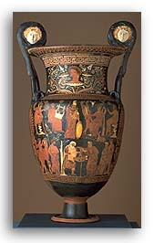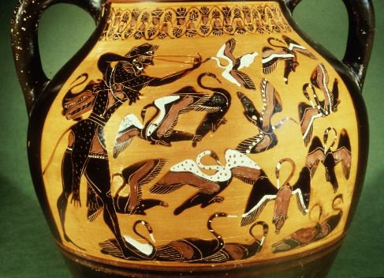

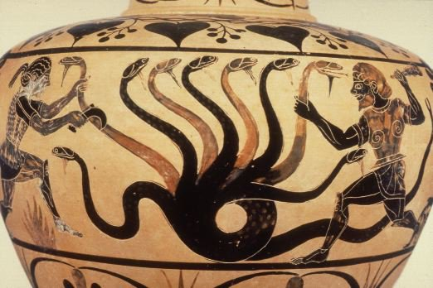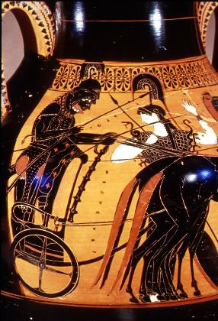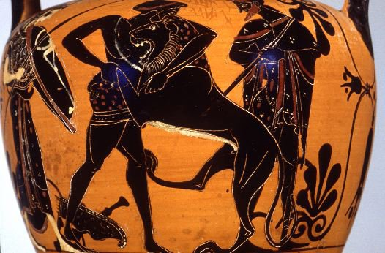

Resources:
Information and images taken from:

Greece: Odyssey On Line http://www.cc.emory.edu/CARLOS/ODYSSEY/GREECE/homepg.html

The Labors of Hercules
http://www.perseus.tufts.edu/Hercules/labors.html

Joel Black
Spring 2002
ED 4140
Creative Expression Methods

