Joel Black
Fall 2000

Math and Literature Lesson

Level: K-2
Time: 45-60 minutes

Lesson Focus:
Counting
Classifying
Equations

Literature links:
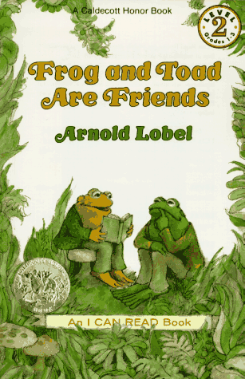
A Lost Button
Author: Arnold Lobel
Frog and Toad Are Friends, Harper Junior Books, 1983
(Frog and toad go for a walk and Toad loses a button. The walk is spoiled, but the button is found after animals help to look for it.)

Buttons poem
Author: Avelyn Davidson
Soldiers, Shorthand (Understanding Mathematics), 1984

Buttons
Buttons in the button box on a rainy day,
Buttons that are fun to sort when it’s too wet to play.
Buttons, buttons, buttons,
Yellow, green and blue,
Red buttons, purple buttons,
Come and sort them too.
Big buttons, brass buttons, shiny round and small,
I would find it difficult to try and count them all.
Buttons, buttons, buttons,
With four holes and with two.
I will sort the buttons and
Make some sets for you
Avelyn Davidson

Goals:
(NH K-12 Mathematics Curriculum Frameworks -- http://www.nheon.org/frameworks/frameworks.html)
1.1 Students will use problem-solving strategies to investigate and understand increasingly complex mathematical content.
1.2 Students will use mathematical reasoning.
2.1 Students will communicate their understanding of mathematics.
2.2 Students will recognize, develop, and explore mathematical connections.
3.1 Students will develop number sense.
3.2 Students will understand the concepts of number operations.
3.3 Students will compute
3.4 Students will use mental computation and estimation skills and strategies and know when it is appropriate to do so

Objectives:
1. Students will listen and/or read the button poem and the Lost Button.
2. Students will act out the story and try to carefully describe the buttons – they choose the buttons they wish and describe them their own way as the story progresses. They may try to match the ones in the story, but it isn’t necessary.
3. The students will work in pairs to count the number of buttons that toad found and then they draw his coat and fasten on the buttons.
4. The students create equations about the number of buttons in the story.

Student example given: “Toad had five buttons on his coat and he lost one. His friends found four. Toad found his lost button. He sewed them on his coat for Frog. Now he has nine buttons.” (5-1+4+1=9)

Learning Styles: V,A,K, and T

Materials Needed:
- A big supply of buttons (and other materials good for classifying and sorting)
- Frog and Toad Story
- Button Poem
- Paper , crayons, or markers
- Glue

Procedure:

- Read the poem Buttons (leave it out so students can use it to look at for reference)
- Read The Lost Button. The students can act it out. It is important that they pay attention to the language they use when they describe the buttons.
- Ask students to choose buttons and describe them in their own way as the story progresses. Also, they may try to find buttons that match the ones in the story.
- Have the students work in pairs with a small pile of buttons. (The teacher can record some of the statements from various groups when they report for discussion)
- The students can count the number of buttons Toad found, draw his coat and stick on the same buttons as those in the text. They can create equations about the number of buttons in the story.
Variation: Give each group (3-4) of students a number of buttons. Students make up their own button story. They draw the coat. They make up a story adventure about how toad lost his buttons (how many he lost, or found…) then the write out the adventure and the number story to go with it. Each member of the group has a job (either writing the story, writing the number story, coloring/drawing the coat and/or scene from the adventure).

Other Activities:
  - Students can pick up a handful of buttons and estimate the number. Then they can count and record the estimate and the count. Doing this frequently will help them develop counting and estimating skills.
  - Students can sort buttons by different characteristics (size, color, holes in the middle) and compare.
Indicators:
- Can students describe the buttons in the text and match them from the button collection?
- Can the students make equations, and explain their equations, for the number of buttons on the jacket? (Toad had 5 buttons on his coat and he lost one. His friends found four. Then Toad found his lost button. The buttons were sewed on. Now Toad has nine buttons. 5-1+4=9…. Etc.)
- What kind of formal or informal mathematical language do students use when sorting and describing their buttons
Resource: Books You Can Count On: Linking Mathematics and Literature (pages 19-20)
Author: Rachel Griffiths and Margaret Clyne
Publisher: Heinemann Portsmouth, NH

