Photoshop Project

Day 1 Overview
- Introduce Photoshop
- Introduce Tools, Layers, Palettes
- Use Brush tool to draw a picture
- Save and Open files
  - Locate files on Network

Start Photoshop

- Click the button on the taskbar.
- Click Programs.
- Locate and click the Photoshop program

When the program launches, a window showing the Photoshop workspace will open.

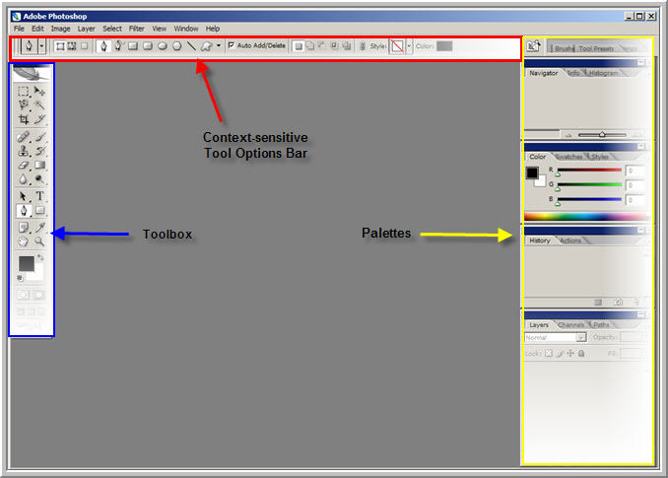

Exploring the Photoshop Workspace:

The title bar at the top of the window displays the program name. (Once you create and save a document, it will also display the name/title of the document.) The title bar also contains the Minimize, Maximize, or Restore Down buttons familiar to Windows.

Underneath the title bar is the menu bar. Clicking on any of the menu titles will bring up a sub menu of various Photoshop commands. Note: commands may be dimmed if they are not currently available to you.

Underneath the menu bar is the tool options bar. The appearance of the tool options bar changes depending on which tool you are using. When you click on a tool in the toolbox the tool options bar displays the options that are available for that particular tool

The toolbox contains the tools you can use with photoshop. You can expand some tools to reveal more tools beneath them. A little triangle on the lower right corner of the tool icon clues you to the presence of additional tools.
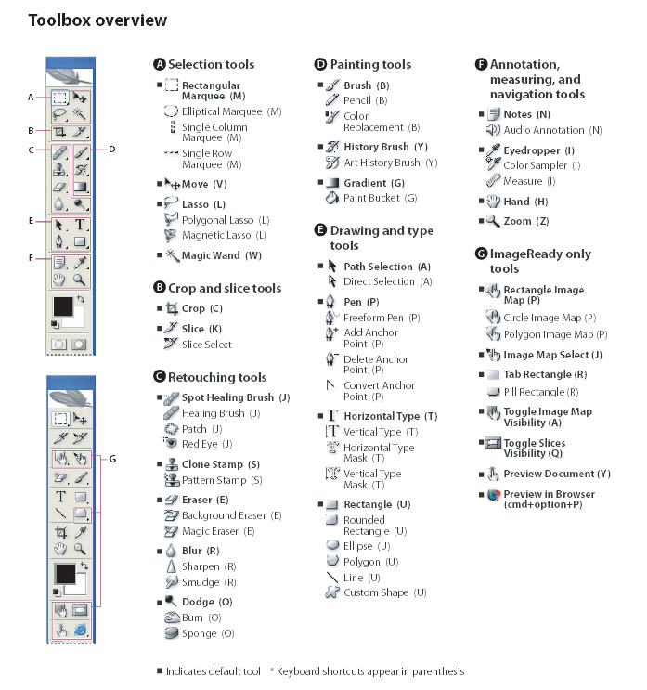
(Above image captured from Photoshop Help File.)
As you can see, there are many tools available in Photoshop. Keeping track of what each one does and how it works can definitely be a challenge.
Consequently, it’s always a good idea to check out the program’s Help feature.
- Click Help on the menu bar
- On the sub- menu, click Photoshop Help. (Also available by clicking F1)
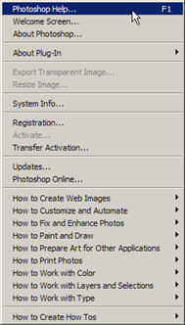

This launches the Adobe Help Center. (See below)
Click an arrow by a topic to locate more information on that topic.
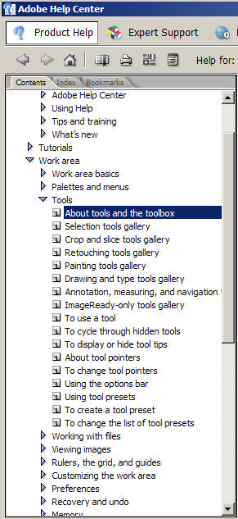 | This part of the Adobe Help Center Window displays the information for the selected topic.

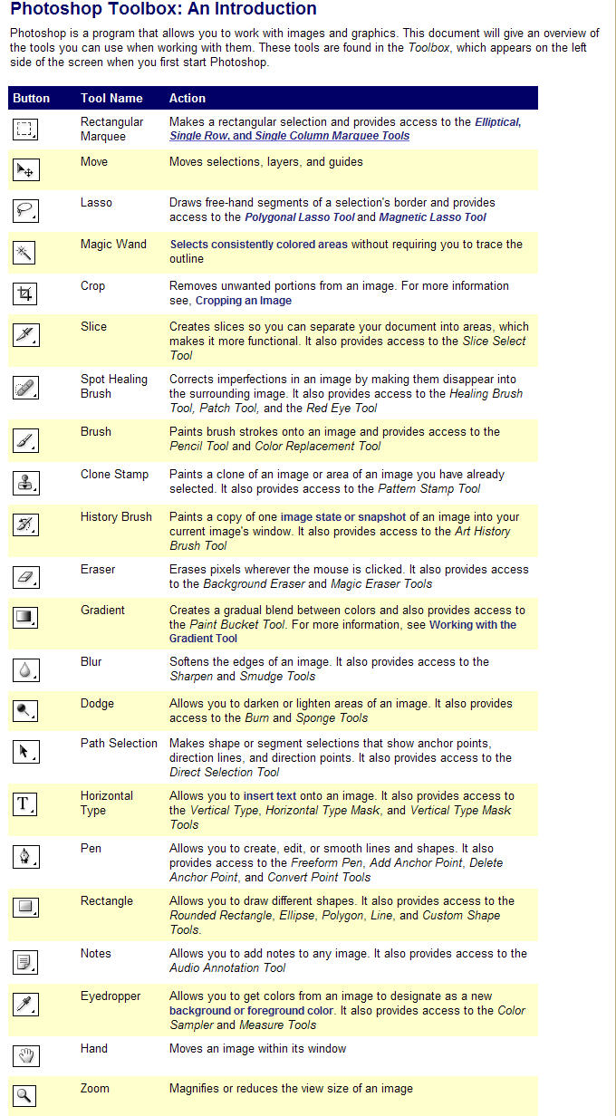
Review the above document to see the basic function of the various Photoshop tools.
Above resource located at: http://www.uwec.edu/help/PhotoshopCS2/toolbox.htm
(The full UWEC Photoshop tutorial http://www.uwec.edu/help/pshopCS2.htm ) is a nice resource.)

Working with Photoshop Palettes:
Photoshop palettes are little windows that can be used to modify documents or check the settings. The palettes usually appear along the right side of the workspace window. Click the palette’s name to make it active. Palettes can be moved and separated by dragging the name tab.
If you “lose” any palettes, you can find them again by clicking Window on the menu bar, and then selecting the ones you want from the submenu that pops up.
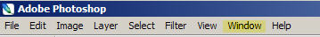

Photoshop Palettes (default settings) | Window Sub-menu
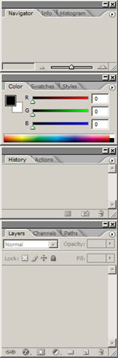 | 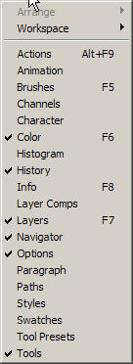

Working with the Layers Palette and understanding layers is the “key” to working with photoshop.

Working with Layers
Layers are like transparent sheets of plastic. Each layer has its own image parts. This enables you to bring in image contents from various sources (as new layers) and put them together to create a composite image. The layers palette shows all of the layers. The first layer in the list is the layer that is on top of the other layers. The visibility icon (which appears as an open eye) indicates that a layer is visible.
Layers Basics Menu from UWEC Photoshop tutorial:

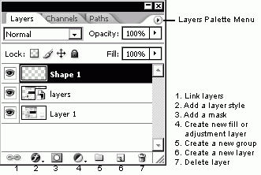

Hopefully, all of this will make sense once we start actually working with Photoshop.

How to Create a New Photoshop Document

- Open Photoshop  - Click File on the menu bar  - Click New  - Double click the number in the “Width” box and type 500  - Click the “Width List” arrow to choose pixels  - Repeat for Height and type 400  - Click OK | 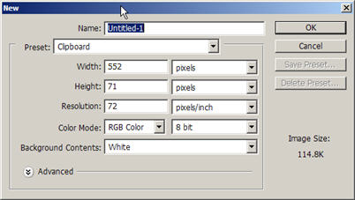

A blank new untitled document appears in the workspace.

We are going to work with the Brush Tool. Notice both the tool option bar and the additional brush tools revealed by right clicking the small triangle in the corner of the Brush Tool button.

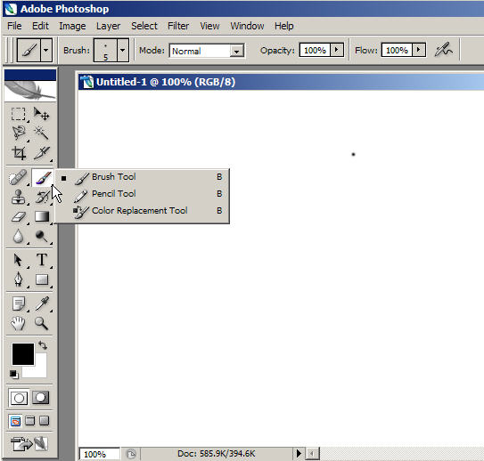

Click in the Brush Tool options bar to reveal more brush options. Click to make a choice.

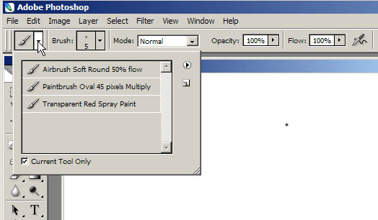

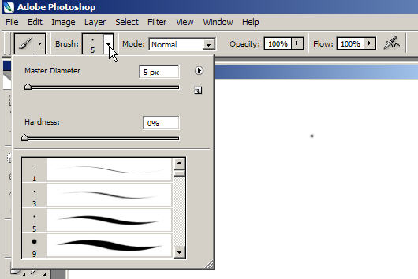
Explore Brush Size options. Click to make a choice.

Experiment with the Brush Tool by holding down the left mouse button and dragging the mouse cursor to draw/paint a subject.

Use the color palette to select different colors. Experiment with various brush sizes and other brush tools.
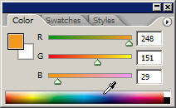

Tip: You can use the Zoom Tool to zoom in for detail work.

If you look at the Layer Palette, you will see that you have created one layer.
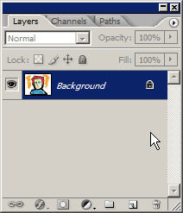

When your image is completed to your satisfaction, you can save it.

Click Save in the File menu. Click the down arrow by the Save in box and locate the folder where you want to save your picture. Double click to open the folder. Then enter a name for your picture in the box next to File name. Then click the Save button

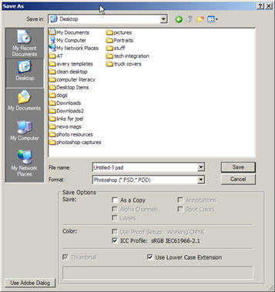 | 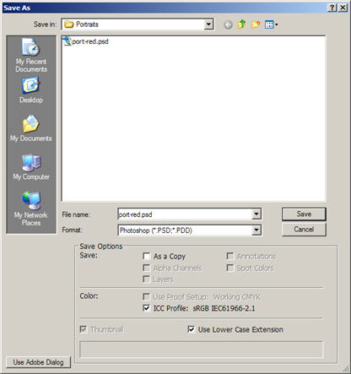

Close the Photoshop program.

Then click Start>Programs>Photoshop to restart the program.
Photoshop opens to the familiar Photoshop Workspace window

This time we will try to locate the file we just saved.
- Click File>Open
- Click the drop down arrow next to the Look in box.
- Locate the folder where you previously saved your image.
- Click to open the folder.
- Double click to open the file
- You should see the image document that you just created and then saved

Add a new Layer using the Text Tool. Click the Text Tool.
Drag a text box in an area on your picture.
Notice that once you select the Text Tool, the Tool Option bar changes to reflect text options. Choose the font, font size and color options that you want. Then type the desired text into the box.
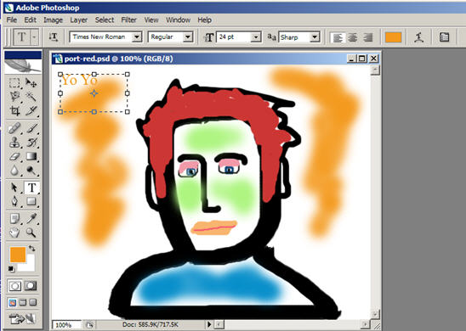

Notice that you now have two layers showing in your layers palette. Adding text automatically creates a new layer.
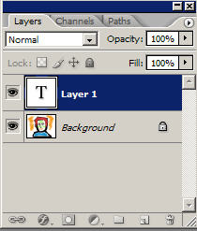

Click File>Save to save your changes and close the Photoshop program.

