Photoshop Project
Part 3 Overview
- Editing individual layers
- Using Clone Stamp, Blur/Sharpen
- Using Filters

Editing Individual Layers

Supposing you put your composite image together and decide that something needs more work. You can always edit the individual layers in Photoshop.
All you need to do is open the image you created. Go to the Layers Palette and hide all of the layers except the one you want to work on.

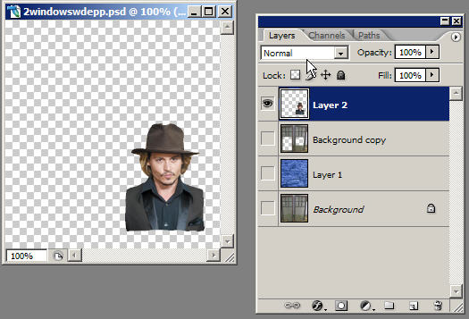

Merging Layers -
Once you have finished you may want to merge layers, this will reduce the size of the image files. Once you save a merged document you can’t go back to the unmerged state - the layers are merged permanently.

Flattening Layers-
Flattening merges all visible layers into the background and gets rid of all the transparent layers. This reduces the file size.

REMEMBER TO SAVE A COPY OF YOUR FILE WITH ALL OF THE LAYERS IN TACT IF YOU WANT TO BE ABLE TO EDIT IT FURTHER. Because once you flatten and the files have been converted, there is NO going back to edit the original

How to do it:
- Be sure that all of the layers you want are visible
- Choose Layer > Flatten Image (Or you can select Flatten Layers from the Layers Palette menu.)

One interesting and fun way you might edit images is to add a filter effect

Working with Filters

Experimenting with filters can add some interesting effects to your work. We will apply a few of the many different filter options to the above portrait layer to compare their appearance. Remember, you need to select the image before you can apply any filters.

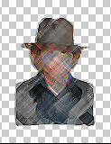 | 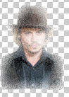 | 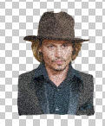 | 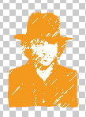
Colored pencil | Diffuse glow | Film Grain | Graphic Pen
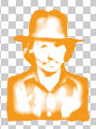 | 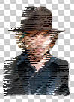 | 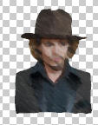 | 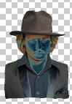
Photocopy | Rough Pastel | Smudge Stick | Solarize

Clone Stamp is another interesting tool. AND, here’s how it works -- straight from Photoshop Help file…. ☺
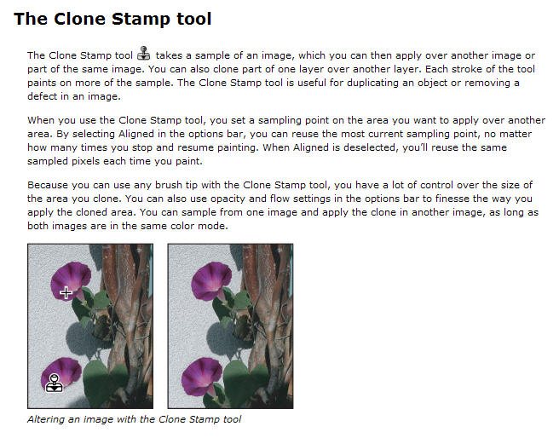
The Pattern Stamp tool allows you to paint with a pattern. You choose a brush tip and set the other options in the Brush Option bar. Select aligned in the options bar. Select a pattern. Then drag in the image to paint the pattern. Experiment! Refer to Photoshop Help if you need to.

Blur and Sharpen
The Blur Tool is sometimes used to soften edges in images and/or reduce some of the detail.
- Select the Blur Tool. Then in the options bar select a brush tip, as well as options for blending mode and strength
- Then select “Use All Layers”. If you don’t select Use All Layers, it will only select the active layer data instead of the data from all layers.
- The drag the cursor over the portions of the image that you want to blur

The Sharpen Tool works the same way except that its purpose is to focus on soft edges in an image to increase the focus and sharpen it. The process is the same as for using the Blur Tool.

